ON AN UNRESOLVED ORIENTATION OF PYRAMIDS
AND CEREMONIAL CENTERS IN MESOAMERICA

Jaroslav Klokočník ¹, Jan Kostelecký ², František Vítek ³

S u m m a r y : Fuson hypothesis (Fuson 1969, Carlson 1975) claims that Olmecs and Maya knew and used a (lodestone) compass (at least) for the orientation of their pyramids, ceremonial and other important buildings (thousand years before Chinese). This hypothesis is tested here with the aid of the new data, namely with paleomagnetic declinations for that time and place (Korte, Bőhnel, 2005). The new test is based also on our measurements at many archaeological localities of Mexico, Guatemala (and Copan in Honduras) by GPS and with a precise compass. After eliminating known astronomical and calendar orientation of some structures, we have found that there is majority of structures with an unexplained orientation. When trying to explain it, we can rule out pure chance, local topography, aestetic, meteorological or defense reasons. Thus, the Fuson hypothesis is still a good tool to describe the observed facts. But more accurate and extensive information mainly from paleomagnetism and archaeology is needed to finally reject or accept the hypothesis. A proof of knowledge of a compass in Mesoamerica (with primacy to Chinese) would be important for our understanding history of the ancient world.

K e y w o r d s : orientation of ceremonial buildings in Mesoamerica, test of Fuson hypo-thesis, Olmecs/Mayan compass, paleomagnetic declinations

Addresses:

1 CEDR (Center for Earth Dynamics Research) - Prague and Ondřejov,
Astronomical Institute, Czech Academy of Sciences CZ-251 65 Ondřejov Observatory,
Czech Republic, jklokocn@asu.cas.cz

CEDR - Prague and Ondřejov, Research Institute of Geodesy, Topography and Cartography, CZ-250 66 Zdiby 98, Czech Republic, kost@fsv.cvut.cz

private: CZ 170 00 Prague 7, Na Maninách 50, ttc.praha@iol.cz

  - INTROUCTION: THE PROBLEM, FUSON HYPOTHEIS
AND QUESTIONS TO BE ANSWERED

Everybody can easily check that various buildings in many archaeological sites of Meso-america are oriented along the cardinal ”north-south” direction (or east-west direction rotated by 90 degrees), but only approximately. Majority of the structures is directed to today’s north geographic (true) pole (of rotation of the Earth) with an east “deflection” or “deviation”; it ranges from 0 to about 35 degrees and nearly always is not so small (typically 10⁰) to be considered error (inaccuracy) of the planning and/or of construction of the objects.

Hard to believe that such alignments are only accidental and not purposeful, especially in the case of Maya, famous for their care and precision and high knowledge of mathematics and astronomy. That special orientation occurs too often to be just by chance, is so spread in space and over times in the whole Mesoamerica, from Olmecs to Mexicians, say from 1500 BC to 1200 AD. Also during various reconstructions, the orientation of the buildings or their parts was often changed, leading to curious irregular shapes of many structures (see e.g. Figs 1a-f); these changes were similar at distant centers (Fuson, 1969). The objection that the building orientation was dictated by the terrain irregularities, local topography or by defense necessities or due to meteorology reasons can not be successful: places like Chitzen Itza are nearly flat and there is the “east deflection” everywhere, and even hilly Palenque site would offer to the ancient “engineers” many choices of the orientation without additional (and abundant) terrain works. Sometimes the orientation defy the local topography: “at some sites there may have been a conscious effort to preserve a particular alignment in spite of the intervening terrain…” (e.g., in Teotihuacan, Calixtlahuacan, Xochicalco), wrote Aveni (1980), p. 237. We can rule out: pure chance, local topography, aestetic reasons, climate, water supply, military defense and similar. There must be for that society very strong (religious?, astrological?) and long time pertaining motivation to keep the orientation in such a strange way.

Figs. 1a-e. show copies of maps/plans of several sites of different cultures and various times in Mesoamerica, namely for Monte Alban (near Oaxaca), Palenque (state Chiapas), Uxmal, and Chitzen Itza (north Yucatan). In our archive we have more examples showing the same trends as in Figs. 1a-e (see Klokočník et al, 2005, web pages: sunkl.asu.cas.cz/~jklokocn). The exact north-south direction or west deviations are rare exceptions (parts of Tikal or Copán, whole Quiringuá, see also Aveni 1980, Fig. 74.)

Fuson (1969) wrote: ”When one considers the obsession the Maya had for mathematical precision, it is difficult to imagine, why he failed to carry it forth in his ultimate creation, the ceremonial center…” Fuson mentioned more than 100 major ceremonial centers on Yucatan (Mexico, Guatemala, Honduras), erected mostly between AD 200 and 1200 (his Fig. 1) and found (by means of geodetic measurements) prevailing east “deflection” (see Figs 1a-e here, also classical book of Morley 1956).

The core of the Fuson hypothesis is the following: Olmecs and Maya used a compass for the orientation of their important buildings. The direction of the compass needle corresponds to
the magnetic north pole at the time of the building construction or its last reconstruction. Due to the fact that the magnetic pole is wandering, the direction to it, as observed from the given
locality, is changing with time. Buildings of various ages then should have different space orientation (different ‘deviations’ from the cardinal direction), i.e. their alignments changed throughout time.

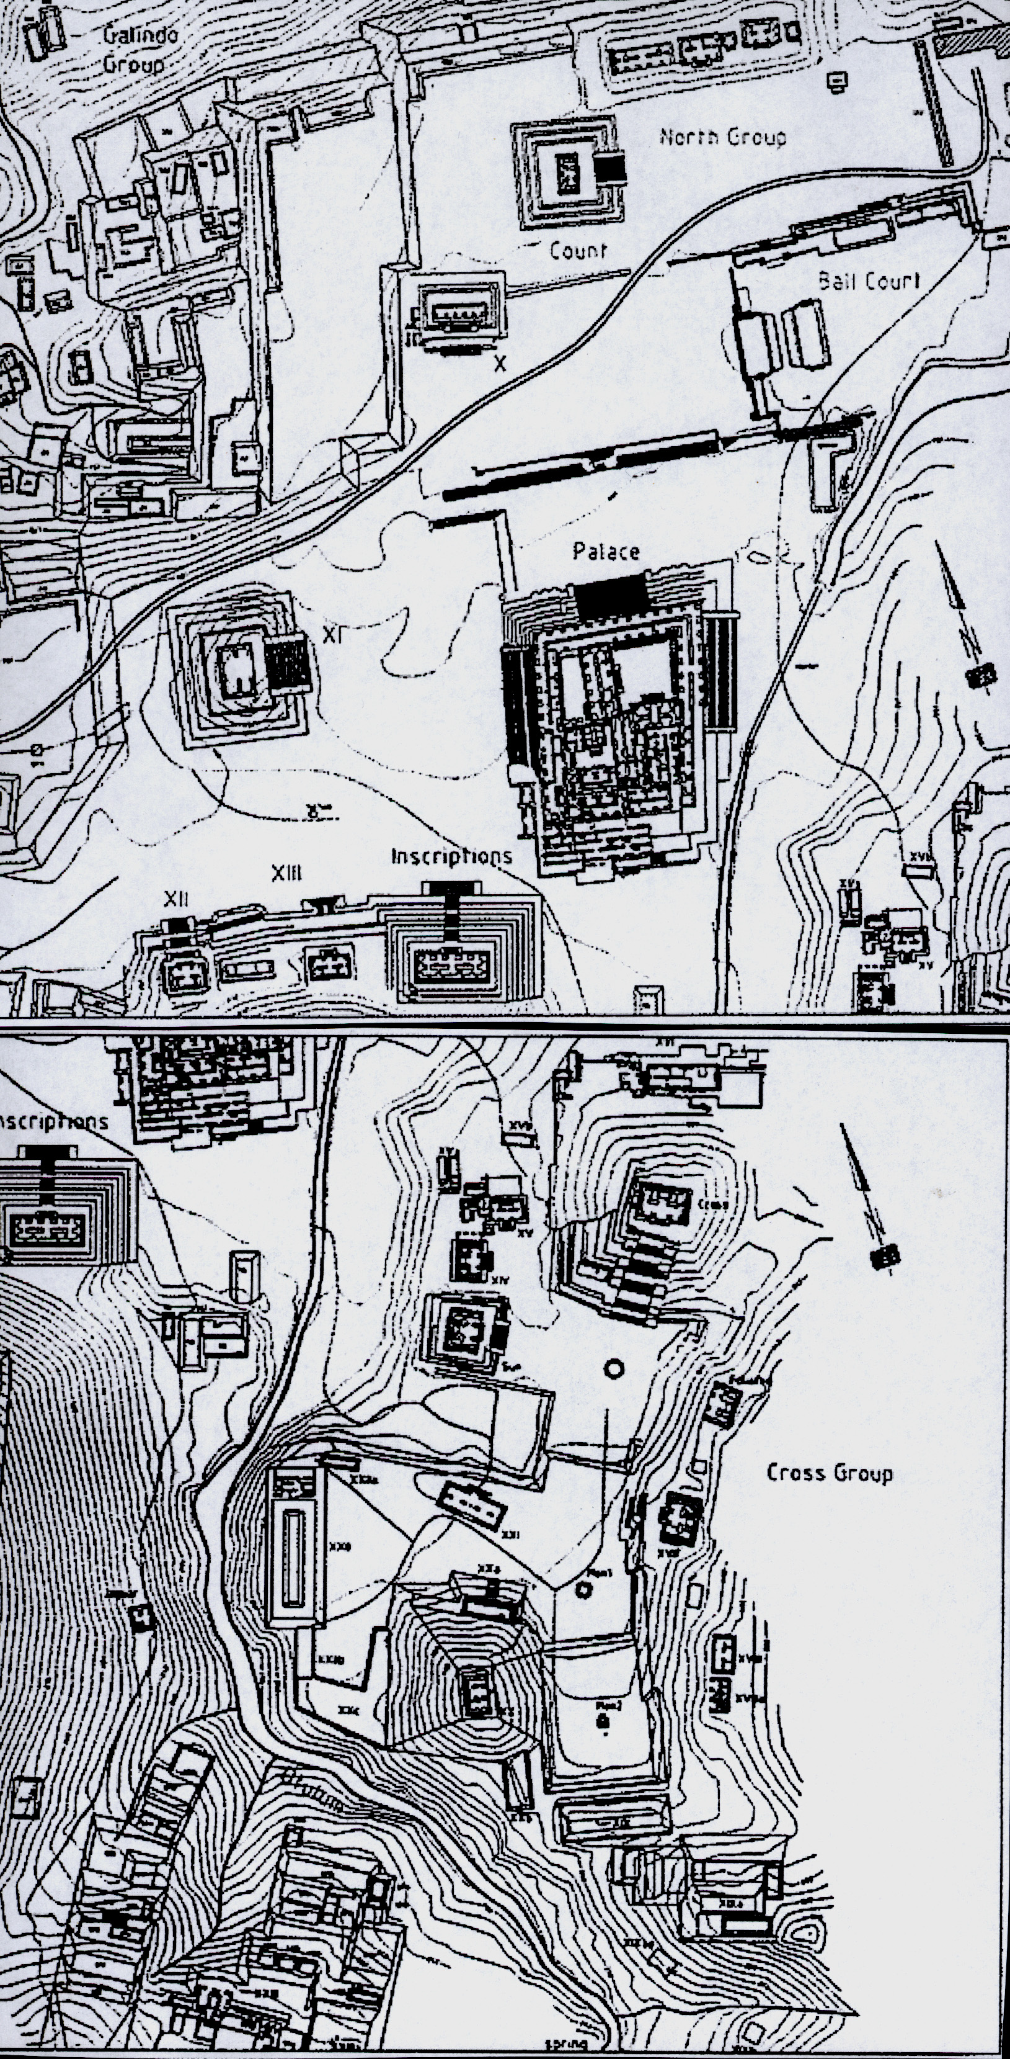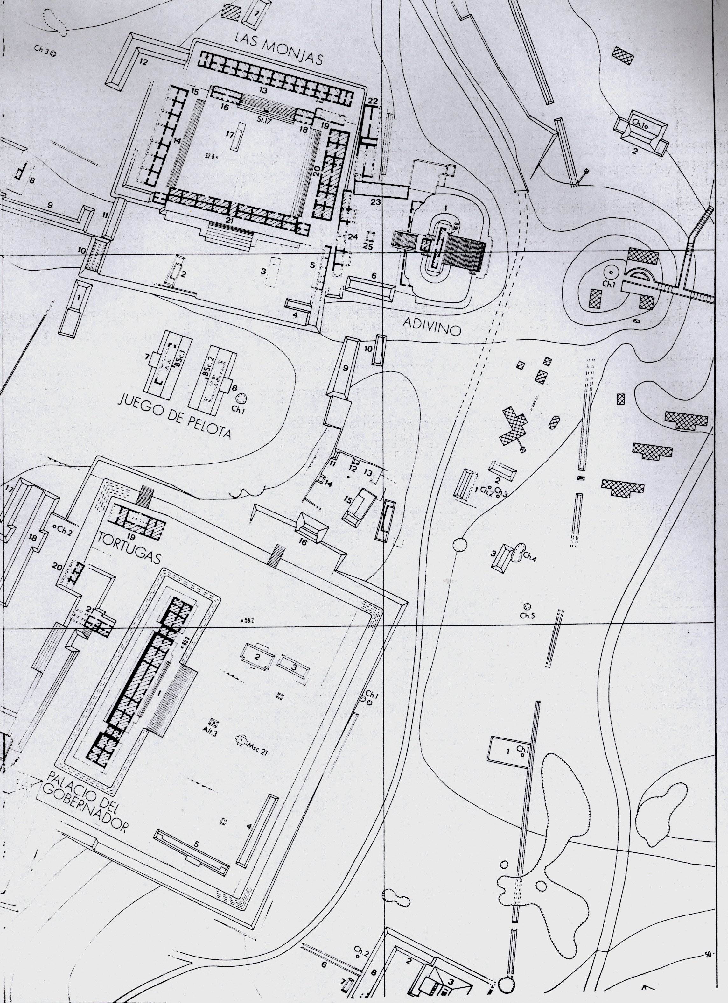

Fig. 1a. Palenque (upper left), a part around the Palace and the pyramids with the temple of Inscriptions (inside with the Pakal thomb), including the pyramid XI, and the North Group; . Fig. 1b. group of the Cross, including pyramid XX. North is shown by the arrows.
according to US mapping project, priv. commun., J. Skidmore (2000), see also: http://www.mesoweb.com/palenque/resources/maps, (© 1998 E. Barnhart).

Fig. 1c (on right). A detailed map of the Uxmal locality (priv. commun. M. A. Falcon,
Mexico City, 2003), showing among others the Oval pyramid with the Temple of Magician and the Palace of Governor. North is up.

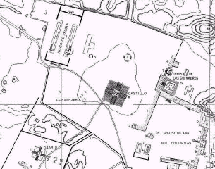

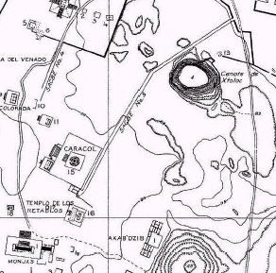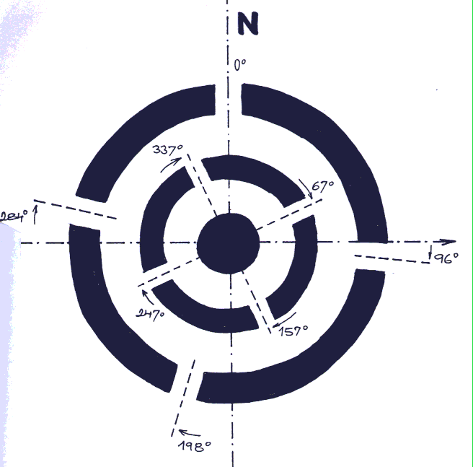

Fig. 1 d, e (left) . Chitzen Itza, around the Quetzalcoatl (Kukulcan) pyramid (e) and Caracol (f). North is from down up. See also http://www.mesoweb.com/chichen/resources/;
Fig. 1f.: Doors of the inner and outer round structures of the observatory Caracol (our own measurements, 2003).

If the hypotheis is valid, then the alignment of the structures and their age are correlated; knowing former we could derive the latter and vice versa. The problem in practice is, however that the accuracy of paleomagnetic and other information is low, or missing at all. A success-ful test of the Fuson hypothesis in time around 1970-1990 was hardly possible due to very limited knowledge of the paleomagnetic declinations for time and place of interest. To repeat a test of the Fuson hypothesis now, we will use the new paleomagnetic data (Korte et al 2005, Bőhnel 2005, priv. commun; for more details see Sect. 3), existing maps of the localities, our own measurements at those places and archaeological information about age of the structures from open literature (mostly Longhen 1998 and Böhm 2003-2005, priv. communs.) as well as from diverse local sources and authorities.

There are several questions: (i) Is the knowledge of the absolute age of the studied archaeological structures available, reliable and precise enough? (ii) Are the maps which are at our disposal sufficiently accurate or have we measured the orientation on the spot by ourselves, how and how precisely? Probably the most important question follows: (iii) Is the reference paleomagnetic declination for the given time period and locality (Olmecs, Maya; Yucatan, etc.) known to a sufficient precision to allow its comparison with the orientation of archeological sites? (see Sects. 4 and 5).

2. NOTE ON KNOWLEDGE OF MAGNETISM IN PRE-COLUMBIAN MESOAMERICA

All facts in this subsection can be found in literature and are repeated here for convenience of the reader. Fuson (1969) and Carlson (1975) wrote about a discovery of the artifact called M160 (Michigan 160 sample), excavated in San Lorenzo, Veracruz, by P. Krotser and M.D. Coe, The M160 is considered to be a lodestone compass, made from mineral which is essen-tially pure hematite (Fe₂O₃). The age of the sample was estimated by C¹⁴ to 1400-1000 BC. From Carlson: […M160 is a] “fragment of a larger piece, broken off in ancient times. The dimensions of M160 are 34 by 9 by 4 mm…The mineral is hard and brittle and its finishing and polishing must have required great skill and much time”. The sample can float on liquid mercury. The materials needed (mercury, magnetite rocks, cinnabar, and limestone) were available on the spot. Methods to prepare liquid mercury from cinnabar (HgS, mercuric sulfide) by roasting in air or with limestone were also known and used by Olmecs and Maya, for painting ceramics and other purposes. The objection that only one sample of a compass was excavated till now, is not fair, because the piece is small; many similar artifacts may still be discovered. The objection that the time interval between Olmecs and Maya is too long to “keep the tradition of the compass alive” is not correct. The Maya was influenced by Olmecs, their cultures were partly overlapping in time (Böhm, 2003, priv. commun).

Malmström (1976) proved knowledge of magnetism in pre-Columbian Mesoamerica by discoveries of the statue of a „magnetic turtle“(frog?) in Izapa (near the Pacific Ocean on boarder with Guatemala) and the statues of „dozen Fat Boys“ in La Democracia (southern Guatemala) unearthed in the late 1940s at a site called Monte Alto. It is nearly sure that these artefacts are not fakes. The ancient local people knew about magnetism and reserved basaltic boulders rich in iron for their carvings. The magnetic turtlehead is a stone 256x144x122 cm large with carvings executed so carefully that the magnetic lines of force came to a focus in the snout of the animal, wrote Malmström. We verified that fact by our own measurements with a precise compass (Klokočník and Vítek, 2005). The carving so precisely located must be intentional and can be achieved only by a compass. The statues of the s/c Fat Boys are of pre-Olmec origin, about 4000 years old (claims Malmström). “The gifted artisans did not insert magnetic rocks into the figures, but apparently carved them around natural magnetic poles in the original basaltic boulders”. A compass at the Fat Boys is directed to the navel of some statues, for others is located in the back of its neck or in their right temples.

These example seems to prove the Olmecs’ primacy over the Chinese discovery of a compass by more than a millennium. Maya, following Olmecs, can utilize the same concept of a compass. It is not surprising that the motivation was pseudo-scientific from our present-day view. It was probably based on their strong believe in something like ‘Chinese’ geomancy, ‘connecting’ cosmos and human beings, used to adapt residences of the living and tombs of the dead so as to cooperate and harmonize with the local current of the ‘cosmic breath’.

3 . ASTRONOMICAL AND CALENDAR ORIENTATION

Astronomically oriented buildings will be rejected from the test of the Fuson hypothesis, so we first of all have to identify them among other structures.

Ancient people certainly used the Sun, namely directions to sunsets or sunrises at equinoxes, solstices and at certain times, important for the local people (time for planting, beginning and end of rainfalls, politically important data like birthdays and deaths of local rules, important persons, gods, etc). In the hilly areas like Cuicilco near the present-day Mexico-City or in the Oaxaca area (Monte Alban, Mitla,…), the technique of using prominent features of the landscape to delineate a solar calendar was used and in some places survives to the present (Galindo, priv. commun. 2003). Solsticially oriented ceremonial centers in Central, Southern Mexico and Guatemala (about 20 localities) were described by Malmström (1978).

The “Sun orientation” requires azimuth exactly 90 (270)⁰ for the equinoxes. The azimuth of the sunset/sunrise a at the solstices can be computed as: cos a = - sin δ / cos φ, where δ is declination of the object (the Sun in our case, δ = 23.5⁰), φ is geocentric latitute of the site of observation. The azimuth of sunset at summer solstice for the north/south Yucatan be-comes a = 64.7 / 65.4⁰ (measured from north to east), and analogically for sunrise/sunset at winter solstice; it yields that east deviation of about 25 degree (rounded) for the cardinal directions of the archaeological structures. [Note also that the azimuth of sunset/sunrise in solstices has been indirectly changed due to precession of the Earth’s axis, but only a little, about 0.3⁰, during the last 2000 years.].

To account also for sets/rising of the Moon and the planets, we have to add few degrees to 25° to acount for inclination of their orbits with respect to ecliptic (7, 5, 3 degress for Mercury, the Moon, and Venus, respectively). The Moon and other celestial bodies, like Venus, were observed, among others, from Caracol (Chitzen Itzá, e.g. already Morley 1956). This extra-ordinary circular building (the „Observatory“) stays on two ramps (platforms) of irregular shape and has doors and windows which enable observations to define directions in specific time for calendar, ceremonial and other purposes (e.g., Morley 1959, Aveni 1980, also here Fig. 1f). Such structures are, however, a rare exception, say one or two pieces per archaeo-logical locality [like Caracol observatory and the Kukulkán pyramid in Chitzen Itzá, the structure #1 (called also the House of Sevel Dolls) in Dzibilchaltún, Uaxactún‘s temples on square of the group E (Guatemala), the building J (called the Observatory) in Monte Albán or the Tower in complex of the Palace in Palenque].

Maya are known to observe Venus (e.g., Morley, 1956; Böhm and Böhm, 1996), so some buildings may be oriented with respect to the extreme directions of Venus’ rise or set, which yields up to 28 degree deviation from the east-west direction to the south. It holds for the observatory of Caracol as well as for example for the s/c Palace of Governor in Uxmal;. this palace probably was not an astronomical observatory, but it is astronomically oriented, the building beeing devoted to the cult of the god Venus. The fasade of the Palace has many glyphs of the planet Venus.

Some structures were equipped by vertical schafts to determine instants of the Sun zenith passes (e.g., Pyramid of Niches in El Tajin, Aveni 1980). They occur in these latitudes twice per year. We estimate that time of the zenith passes might be predicted with error of 1-2 days (Klokočník and Vítek, 2005).

A further investigation may discover more and more connections between space orientation of various archeological structures and calendar (directions of the Sun rises/sets at specific agricultural seasons, at datums important for the local society, etc.), which are now still hidden to us or we do not understand them.

Let us take Fig. 2, summarizing the alignments (the deflections from the cardial direction) of many buildings in Mesoamerica (according to Aveni, 1980). The prevailing east deviations are evident. But (i) for the calendar explanation one would expect more regular distribution of the directions in the „fan“ on Fig. 2, with both east and west declinations during the whole calendar year. We may speculate that (ii) if the directions are based on certain datums connected for example to the begining of a contruction of the buildings, then the distribution of the east and west declinations should also be more or less regular during year, excluding possibly the interval of heavy rains. (iii) The rains on Yucatan prevail from May to October. But the remaining months ‚without rains‘ correspond to both east and west declinations. Thus, the prevailing east deflections on Fig 2 remain unexplained when we rely upon calendar only.

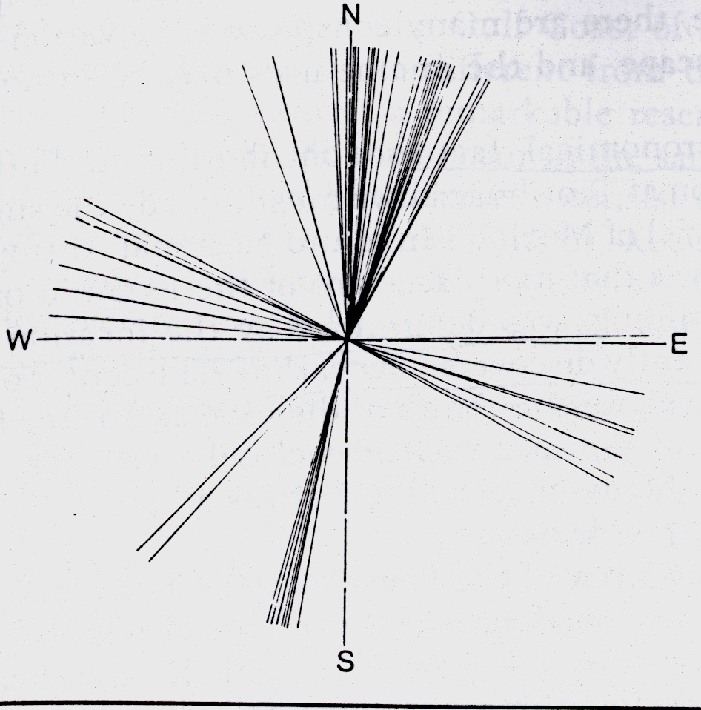

Fig. 2. A “fan” of declinations around the cardinal north-south (west-east) directions of the structures at various ceremonial centers in Mesoamerica (according to Aveni, 1980).

Note that the vertical dimensions of a building should not be overlooked in any study of the building orientation. There is nowhere an ideal horizon. Aveni (1980) wrote: ”By varying the height of the observer relative to the foresight,…, it may be possible to account for many of the orientations skewed 0 to 10° eastward from the cardinal points by sunrise observations at the equinox. Alignments with a larger skew could be explained by a sunrise of sunset observation on one of the significant agricultural, civic or religious dates of the year…” One has to agree with Aveni; he may partly explain the orientation of the structures for hilly localities (like Monte Alban, Mitla, Palenque) but does not explain the observed present-day east deviations on localities in plain terrain (e.g., Uxmal, Kabah, Labná, Sayil, Dzibilchaltún, Chitzen Itzá, Cóba, Tikal, Uaxactun, Izapa,…).

In conclusion to this Section: we see that a significant minority of the buildings has an astronomical orientation or meaning (see also Fig 74 in Aveni, 1980, or Appendix A of that book, and Table below). There is a small portion of proved astronomical observatories and astronomicaly orientated structures. The other explanations (namely the calendar hypothesis and its various alternatives) are only partially successfull and only locally applicable.

4. DATA

4.1. Paleomagnetic pole wandering and declination

Since the litospheric motions and the secular motion of the geographic pole (i.e. the pole of rotation of the Earth’s body) are much slower and smaller on the interval of few thousand years than the “erratic wobbling” of the magnetic pole, we can - for our purpose - neglect the former. The magnetic pole wandering has a huge amplitude, is irregular, fast, but has tendency to be periodic (see, e.g., McElhinny and McFadden, 2000, p. 23; E&F).

In the 70ties of 20th century, the knowledge of the magnetic declinations and inclinations and of the paleomagnetic pole wandering was very poor to prove the Fuson hypothesis. Later (Creer and Tucholka, 1982; Creer, 1988) provided better results, but not for Yucatan. Bucha (1990) used the Creer’s data (Creer, 1988) and constructed curves of wandering of north paleomagnetic pole with respect to true geographic pole. More analyses have appeared mean-ime (e.g., Hongre et al, 1998; Bőhnel and Molina-Garza, 2002) and the Bucha’s result has been superseeded (Ohno and Hamano, 1992; E&F 2000). The accuracy of the pole positions was low (error ~ 5 degrees, Bucha’s private commun., 2001). For the results presented in E&F it hardly will be much better.

The work of Hagstrum and Champion (2002) [H&Ch] has been evaluated by Bőhnel (2006, priv. commun.) as excellent, based on an enormous number of dated lava flows, representing west of USA. Recently Korte et al (2005) [Korte] published the global model CALS7K, where the H&Ch data is used as one data subset. The model should be reliable for the time span 0 BC – 1950 AD, due to a lot of data also from Mesoamerica, but back in time the data from that region is sparse. According to Korte and Bőhnel (2004, 2005, priv. communs.), the accuracy of the best paleomagnetic declinations now available is between 3 and 6 degrees for the area and time of our interest.
Korte kindly provided us with the curve of the paleomagnetic declinations, calculated from her global model for Yucatan. Bőhnel kindly transformed for us the curve from H&Ch, also for Yucatan (Merida). These two curves are together, with the paleomagnetic declinations derived from the pole positions taken from E&F and with the original curve for north America from H&Ch, shown in Fig. 3. Although the curve from E&F is not adequate for any compa-rison with the others, there is its “east excursions” of the declination around 800 BP (before present), common to all results. All other curves agree well on a significant east declination near 1000 BP, with amplitude about 15⁰. Unfortunately Korte’s and H&Ch curves mutually do not agree in the interval around 2200-1500 BP, which is one of important periods for the Maya. There is a similar trend, but different magnitudes of the west declination around 2400 BP. Korte’s model is a comprehensive but a global model, which may ignore local magnetic anomalies. Bőhnel’s curve should be tailored to Yucatan, so we accept it for our analysis.

Obviously much work has to be done to provide scientific community by reliable and accurate paleomagnetic declinations for the time interval 4000-1000 BP. The main problem is (Bőhnel 2006, priv. commun.) the precise and absolute age determination of a rock and the precise paleomagnetic determination. Even the best data now available will complicate testing of the Fuson hypothesis. We take the Bőhnel curve from Fig. 3 as the reference for our work and accept that its accuracy is only about ± 5⁰.

Fig. 3. Paleomagnetic declinations during last 4000 years, according to various sources. Negative is to east from north on this figure. Explanation in the text. The reference curve for our work, after several consultations (Bőhnel, Korte, priv. commun. 2005, 2006) is the thick red one.

4.2. Maya calendar: its correlation to our calendar .

The following obstacle for our research may seems surprising: mayanists do not know correct relationship of the Maya calendar (expressed in s/c Long Count, MD) to our “christian” calendar (may be expressed in Julian Days, JD). This problem is known as “the correlation problem”. According to the traditional and often used Goodman-Martinez-Thompson [GMT] correlation (e.g., Thompson, 1935), we need to add 584285 days to MJ to get JD. However, there are serious objections against GMT (e.g., Vollemaere 1994, Böhm and Böhm, 1996, or Verbelen, 2000). When astronomical observations (like aspects of the planets and eclipses), which has been decoded from the famous Maya’s picture book called Dresden Codex (DC), were analyzed, one found that the values of the “correlation” differs dramatically from the GMT value. Vollemaere (Vol) found 774080 days, Böhm and Böhm (B+B) 622261 days and Verbelen (Verb) 739615 days. The difference is huge, e.g. 520 years(!!) between GMT and Vol, and 104 years between GMT and B+B (in both cases the history by Vol, Ver or B+B correlation is shifted in direction to our present time). The uncertain “timing” between Maya and our culture is an additional big obstacle for our testing because the alignment may change significantly during 100 years (see Fig. 3 for the time interval around 1000 AD).

4.3. Age of structures: information from archaeology

Archaeologists often do not provide absolute age of the structures of our interest. Sometimes relative age is known and also this may be very problematic. If the age of an object would be known for sure, then we would be able to calibrate our method to test Fuson hypothesis. But information about the absolute age is often missing.

The radiocarbon dating by C¹⁴ suffers from a great uncertainty, about ±100 years for the time of our interest. Some examples of dates discovered by C¹⁴: Chitzen Itza 883-891 (GMT), Balankanche 968-979, Isla Cerritos 960-1039, Ek Balam 888, and Uxmal 982 AD (Withmore et al, 1996; Ringle et al, 1991).

We have a general information about the age at different archaeological localities and specific information about age of several particular structures.

Example 1. The pyramid XX in Palenque: irregular shape, east part is older than the others, the western wall (in bad shape now) is the youngest, located above a spring (my be flooded), after a reconstruction. The time difference between the oldest and youngest parts is estimated to be 300 years.

Example 2. The Palace in Palenque: significantly irregular shape of its outer as well as inner walls; higher east deviation for the eastern, older walls; southern outer steps are the youngest.
The Tower, sometimes called Observatory, is newer. The absolute age is uncertain.

Example 3. The structure #44 in Dzibilchaltun: the inner, older part is from 400-600 AD, the outer layer from 800-1000 AD. The difference in the orientation is 2 degrees, but this is too small to be statistically significant, accounting for our measuring precision of the directions by the compass.

Example 4. Caracol, Chitzen Itza: the upper platform and the outer part of the circular building itself must be younger (1000 AD?) than the lower platform and the inner part of the round structure (900 AD?).

Example 5. El Tajín. The northern part of the locality on the hill is younger (950-1100, GMT) than “plain” southern part (300-700 AD). The pyramid of Niches is from 10th century (Zubiri and Gomez, local archeologists, 2005, priv. commun.).

Example 6. Copán. The gold age from 426-820 AD (GMT), but first stone structures from 9th century BC, the newest record from 1200 AD, stairs with hyeroglyphs from 755. The age of many stelae is similar.

Example 7. Tikal. The oldest record from 292 AD (GMT), the boom in 6th-8th century AD, decline around 900. Tikal underwent many reconstructions, so what we can see now is mostly from about 8th century. The oldest stela in the close locality of Uaxactún is from 327, the newest from 889 AD (GMT).

Example 8. Monte Albán was established by Zapotecs in 5th-7th cent. BC, but the best years belong to 5th-8th cent. AD. There is 5 etaps of evolution of this locality; what we can see now is mostly Monte Albán III from 300-750 AD (GMT). The extraordinary building J, known also as the “Observatory” comes from 1st cent. BC – 2nd cent. AD.
We have a table with about 1200 items from about 70 archaelogical sites in Mesoamerica with information on the age of the objects (on stelae, throne, name of nearest palace, temple, pyramid, etc) in Maya date (Böhm, Fuls, 2001, 2005, priv. communs.). The archaelogically discovered datums on stelas or buildings relate to times of dead/born of important persons, like local rules, to meteorological phenomena, to the begining of the world according to Maya, etc. It is difficult to correlate these datums with the date of begining of a construction of a ceremonial center or individual building. Something is fortunately known about urbanistic planning of Maya towns. The age of a center can be estimated from minimum and maximum ages mentioned on stellas and other objects. With the aid of Böhm (2001, priv. commun.), we rely upon the following facts: (1) buildings in Copan, 1 305 000 – 1 429 200 days, i.e. 564 – 904 AD (using always the B+B correlation) have small east and west deviations (different in various parts of the locality), (2) Chitzen Itza (1 453 433 – 1 458 764 = 970 – 985) has strong east deviation, Figs. 1d-e (many reconstructions took the place here, e.g., after 985 AD by Toltecs), (3) Palenque (1 369 800 – 1 423 800 = 741 - 889) has majority of buildings with east declination, Figs 1a-b, and (4) Uxmal (1 465 874 – 1468 272 = 1005 - 1011) also, Fig. 1c.

It is important that the Fuson hypothesis permits positive, zero as well as negative deviations, depending on age. Note also that the correlation “age vs orientation” is not unique, because of periodic character of the magnetic pole wobbling; the azimuth can be similar for distant epochs (Fig. 3).

4.4. Maps

Maps from various sources are available and often are not sufficiently reliable. Even in Palenque we found mistakes in the maps from the US geodetic measurements. For example, Fig 1a shows the pyramid XI (near the Temple of Inscriptions), which is in reality just a mound with trees. The irregular shape of the pyramid XX (Fig 1b), probably after some reconstructions, is difficult to verify, because they are only ruins there. In Monte Alban, the structure J, s/c Observatory, has a wrong orientation on some maps (e.g., in Longhen 1998, p. 153, or Aveni, 1980, p. 257, diagram provided by H. Hartung). In Chitzen Itza, the round structure of the Observatory, known as the Caracol, has on some maps wrong orientation of its doors (also in Aveni 1980, p.261); for the correct scheme see Fig 1g based on our measurements. The northern front part of the Palace in Sayil is shown in a wrong way in Longhen 1998, p. 279 (it has direction to the true north pole). Thus, it was necessary to make our own measurements on some sites. We show as example of our results (measurements by the compass) the Caracol (Klokočník and Vítek, 2005).

For Uxmal, we have two maps, one from Morley’s book (1956) and better one from the archive of M. Falcon (Mexico City, 2003, priv. commun.), and we have also our own results from GPS and compass measurements. We used that best map to measure azimuths directly from the map, by means of measuring instrument Autocad 2004LT. Then we compared the results with our measurements. Excluding the Ball Court, the computed and measured azimuths agree well, within 1⁰ (for less well defined, tortuous or partly destroyed structures within about ±2⁰).

For future research a deep inspection is needed through all possible map archives with archae-ological sites in Mexico and around and subsequent geodetic measurements are needed where no reliable maps will be at disposal

5. MEASUREMENTS

In November-December 2003, and in March-April 2005, we measured by handy GPS Garmin eTrex Vista and by a special compass (for precise mining measurements). We have about 20 baselines measured with the GPS at 14 different archaeological localities. We measured approximately 300 points by the compass. The visited localities were: Mitla, Monte Albán, Villahermosa, Palenque, Uxmal, Sayil, Kaban, Labná, Dzibilchaltun, Chitzen Itza, Cobá, and Tulum in 2003; Teotihuacan, El Tajín, Tres Zapotes, Izapa, Kaminaluyú, Copán, Quiriguá, Tikal, and Uaxactún in 2005.

The correction from the magnetic a to the astronomical azimuth a_{astr} is as follows: a_{astr} = a + corr., where a_{astr} refers to the pole of rotation of the Earth, and is measured by means of GPS; a refers to the north magnetic pole of the Earth, and measured is by a compass.

The correction „corr“ can be derived from measurements by GPS on the spot or can be taken from the model of NGDC NOAA (see www.ngdc.noaa.gov/seg/potfld). The model provides inevitably smoothed values and ignores possible local anomalies of the magnetic field. For Mexico today, the correction has small positive value.

Precision of our GPS measurements with Garmin eTrex Vista is several metres in geocentric positions. With the baselines length 0.5 km, we guarantee 1-2 degree of its directional precision. From the baseline measurements both by GPS and by the compass we can compute the difference (“cor”).

Precision of our compass measurements is estimated to be m_{comp} = 1-2⁰ (derived from a calibration test before the field measurements on accurately known GPS baselines at the Geodetic Observatory Pecný, Czech Republic). Resolution of the NGDC model is estimated to be about 500x500 km (a half wavelength for series of magnetic declination in spherical harmonics expansion to degree and order 10), yielding precision of the magnetic declination not better than m_{model} = 1⁰ (Hejda, 2003, priv. commun). Rms of „cor“, consisting of both components m_{model} and m_{comp}, is then roughly 2⁰.

Variations of the magnetic declination with time are slow on a month scale; therefore, we accepted the values from the NGDC model for mid of our epoch of measurements in 2003 and 2005. A possible local variability during day was ignored. Possible local anomalies, created by geology structures, might be very large - to several degrees. It is necessary to employ local GPS baselines at least one per site. We also have experience with local „artificial“ anomalies of order 10⁰ due to electric cabels located shallowly beneath the surface of some of reconstructed objects. The relevant measurements were identified and removed from further processing. Geomagnetic activity can change the declination as much as 2⁰ in extremum cases (Hejda, 2003, priv. commun.).

The corrections accepted for our interpretations are usually a compromise between two smothed model values and possible biased values from the local measurements on too short baselines (there was not enough space for the longer baselines). More in Klokočník and Vítek (2005).

6. RESULTS

Considering the age of the structures (Sect 4.3 and more), the estimated paleomagnetic pole positions as observed at time of possible construction (or probable last reconstruction), Fig3, and taking the measurements of the directions of the buildings from GPS and compass or from the maps (our archive), we mark in Table by sign “+” those structures, where we see a fair support for the Fuson hypothesis. The Table contains the result of our work.

Table with results of our measurements

structure |  | age(GMT)* |  |  | declination | Fuson | comments
 |  |  |  |  | degree(east)
Mitla |  | 950-1521 AD
group Arroyo |  | 950-1521 |  |  | 12 | +
group of columns |  | 950-1521 |  |  | 11 | +
temple group |  | 950-1521 |  |  | 13 | +
Monte Albán |  | 500BC - 950AD
B |  | 500-750 |  |  | 5 | +
D |  | 500-750 |  |  | 8 | +
E |  | 500-750 |  |  | 4 | +
F |  | 500-750 |  |  | 5 | +
G,H,I |  | 500-750 |  |  | 3 | +
structure J, Dancers |  | 500BC - 100 BC |  |  | 3 | +
K |  | 500-750 |  |  | 6 | +
structure L, Observatory |  | 100 BC - 200 AD |  |  | 0 | ? | astronom.orient.?
M |  | 500-750 |  |  | 6 | +
N |  | 500-750 |  |  | 5 | +
O |  | 500-750 |  |  | 6 | +
Palenque |  | 300-900 AD
palace-exterier |  | 300-700 |  |  | 14 - 24 | +? | irregular 1
palace-interier |  | 300-700 |  |  | 12 - 22 | +? | irregular 2
palace-tower |  | newer |  |  | 14 | +?
north group |  |  |  |  | 14 - 19 | +?
Pacal exterier |  | about 600 |  |  | 22 | +?
Pacal thomb |  | 600-700 |  |  | 26 | - | orient. to Sun
Cross group, pyramid of Cross |  | 670-695 |  |  | 33 - 35 | ?
Cross group, pyramid of Sun |  | 690 |  |  | 30 | ?
pyramid XX |  |  |  |  | 14 - 24 | +? | wall at spring, 3
pyramid XXI |  |  |  |  | 16 | +?
Uxmal |  | 100-1200 AD
Temple of Magician |  | 600-900 |  |  | 9 | +
Nunnery Quadrangle |  | 900-1000 |  |  | 11 - 19 | + | irregular 4
ball court |  | 900-1000 |  |  | 10 | +
Palace of governor |  | 900-1000 |  |  | 28 | - | to Venus
Great pyramid |  |  |  |  | 17 - 18 | +
Southern temple |  |  |  |  | 6 | +
House of doves/south.group |  |  |  |  | 9 | +
Labná |  | 700-1000 AD
palace |  |  |  |  | 18 | ?
sacbe(at El Arco) |  |  |  |  | 1 | ?
Sayil |  | 700-1000 AD
palace sout.wing |  |  |  |  | 2 | ? | irregular 5
palace north.wing |  |  |  |  | 21 | ?
Kabah |  | 700-1000 AD
palace |  |  |  |  | 16 | +?
palace of masks |  |  |  |  | 17 | +?
Dzibilchaltún |  | 600-1000 AD
temple of 7 dools, structure 1 |  | 600-700 |  |  | 2 - 4 | - | observatory?
structure 44 outside/inside |  | 800-1000,400-600 |  |  | 10, 12 | +
structure 36, small pyramid |  |  |  |  | 22 | ?
Chichén Itzá |  | 600-1250 AD
Castillo |  |  |  |  | 24 | - | orient. to Sun
Temple of bearded man |  |  |  |  | 16 - 18 | +
platform of Venus |  |  |  |  | 19 | +
ball court |  |  |  |  | 19 | +
Osario/Ossuary |  |  |  |  | 17 - 19 | +
Temple of warriors |  |  |  |  | 20 | +
Retablos |  | 600-1000 |  |  | 14 | +
Akab´dzib |  |  |  |  | 24 | ? | orient. to Sun?
Nunnery complex |  | 800 |  |  | 13-15 | + | see 6
Caracol lower platform |  | 800 - 900 |  |  | 18 - 28 | + | irregular 7
Caracol upper platform |  | 900-1000 |  |  | 15 - 22 | + | irregular 7
Caracol Observatory, tower |  | 900-1000 |  |  | circular | - | observatory, 8
Tulum |  | 1000-1521 AD
Castillo, upper part at temple |  |  |  |  | 25 | - | orient. to Sun
C -part |  |  |  |  | 33 | -
C -part |  |  |  |  | 28 | - | see 9
cemetery platform |  |  |  |  | 28 | -
Kaminaljuyú |  | 1200 BC-900AD
palace |  |  |  |  | 32 | -
Copán |  | ?550-850 AD
great plaza |  |  |  |  | -4 | +?
pelota |  |  |  |  | -3 | +?
court at steps with inscriptions |  |  |  |  | -3 | +?
east court |  |  |  |  | 5 | +?
west court |  |  |  |  | 6 | +?
Quiriguá |  | ?250-900 AD
acropolis |  |  |  |  | -13 | -
Tikal |  | ?300-900 AD
central acropolis |  |  |  |  | 9-17 | +
pelota |  |  |  |  | 10 | +
pyramid #1 |  |  |  |  | 10 | +
north acropolis |  |  |  |  | 7-13 | +
pyramid #2 |  |  |  |  | 10 | +
plaza of the Lost world |  |  |  |  | 4-10 | +
plaza of the Seven temples |  |  |  |  | 3 | +
complex Q |  |  |  |  | 5 | +
complex R, O |  |  |  |  | 4 | +
pyramids #4 |  |  |  |  | 10 | +
Temple of Inscriptions |  |  |  |  | 7-12 | +
Uaxactún |  | 250-950 AD
complex E |  |  |  |  | 5 | +? | 10
group C |  |  |  |  | 4 | +?
group A, palace 12 |  |  |  |  | 11 | +?
group A, plaza |  |  |  |  | 6 | +?
group A - palace 5 |  |  |  |  | 2 | +?
Izapa |  | 1250BC-850AD
group F, pelota |  |  |  |  | 23 | - | orient. to Sun
group F, west structure |  |  |  |  | 26 | - | '
group F, east structure |  |  |  |  | 22 | - | '
group B, stelae |  |  |  |  | 23 | - | '
El Tajin |  | 250 - 1000 AD
Pyramid of the Niches |  | 1000 AD |  |  | 10 | ? | orient. to Sun?
Chico Plaza |  |  |  |  | 31- 45 | -
Xicalcolliuhqui |  |  |  |  | 40 | -
edificio 3 |  |  |  |  | 11 | +?
edificio 4 |  |  |  |  | 29 | -
edificio 5 |  |  |  |  | 3 | +?
edificio 12 |  |  |  |  | 4 | +?
edificio16 |  |  |  |  | 6 | +?
edificio 18 |  |  |  |  | 14 | +?
edificio 20 |  |  |  |  | 2 | +?
edificio 22 |  |  |  |  | 19 | +?
edificio 23 |  |  |  |  | 10 | +?
pelota I |  |  |  |  | 0 | +?
pelota II |  |  |  |  | 10 | +?
pelota III |  |  |  |  | 13 | +?
comments: | * to transform age from GMT to B+B, one has to add 104 years to GMT
1 | irregular shape, higher declination for east, older walls, southern
 | steps are the youngest, absolute age n/a
2 | irregular shape,the highest declination for eastern wall, absolute age n/a
3 | in bad, irregular shape, east part older than the others, western youngest
 | (localed above a spring, probably flooded, reconstructed); the difference between
 | the oldest and youngest parts of this structure is about 300 years
4 | irregular shape, measurements on the spot plus reading from excellent
 | map available is wrong, the northern part of the fasade with steps is (see text)
5 | map available is wrong, the northern part of the fasade with steps is
 | oriented to the true pole, while the southern has declination about 28 degrees
 | east of north.
6 | in bad shape, difficult to measure
7 | significantly irregular shape, the upper platform less inclined
8 | the tower has inner and outer doors, see our Fig. 7; the inner doors have evidently
 | orientation to the Sun rise/set at the solstices; the orientation of outer doors is not
 | yet fully understood. The windows at the upper part of Caracol have astronomical
 | meaning (Morley 1956, Aveni 1980, and others).
9 | northern part of structure C is significantly more inclined to east
 | than the southern part
10 | complex E contains astronomical (solar) observatory

From Table 2, it follows that majority of the structures might be oriented according to the magnetic pole in time of their construction or reconstruction. But more archaeological data, more geodetic measurements on more places or more precise maps are needed to finally support of reject the hypothesis. As a crucial problem we see insufficient reliability of the paleomagnetic declinations now available. One has to wait (may be a longer time) for some improvement (Korte 2006, priv. commun.). Till that time we guess that final proof or rejection of the Fuson hypothesis is impossible.

- CONCLUSION

The Fuson hypothesis about possible orientation of Maya and other ceremonial centers by (paleo)magnetic pole, using (a lodestone) compass cannot be simply rejected in the light of existing facts; it still provides an explanation for the strange alignments, where the other interpretation are not helpful. Our new measurements and computations from 2003-2005 support the hypothesis. More precise and more extensive information from geodesy (more reliable and detailed maps of the archaeological localities), from astronomy (the correlation between Mayan and our calendar), from archaeology (age of the structures, namely the absolute age), and namely better paleomagnetic/archaeomagnetic data are needed to finally reject or accept that Olmecs/Maya actually used the compass. If they knew and used a compass (well before Chinese), then one has to think about rewriting a part of history of ancient world.

References

Aveni A. F., 1980: Skywatchers of Ancient Mexico, Univ. Texas Press, Austin and London.

Böhnel H. and Molina-Garza R., 2002: Secular Variation in Mexico during the last 40,000 years, Physics Earth and Planet Int. 133, 99-109.

Böhm B. and Böhm V., 1996: Results of Mayan Astronomy in the Dresden Codex and Correlation of the Maya System of Dating with the Christian One, XIII Interntl. Congress of Prehistoric and Protohistoric Sciences, Forlí, Italy, Sept., Proceddings, pp. 544—545.

Böhm B. and Böhm V., 1999: The Dresden Codex: the Book of Mayan Astronomy,
America Antiqua III, Flemish Inst. for American Cultures, Yearbook 1999.

Bucha V., 1990: Variability of Orbital Characteristics of the Earth, of the Geomagnetic
Field, Solar Activity, Climate and Weather (in Czech), pp. 7 – 45; in „Vztahy Slunce-
Země“, Proceedings Symp. in Stará Lesná, Geophys. Inst. Slovak Acad. Sci., Bratislava.

Carlson J.B., 1975: Lodestone Compass: Chinese or Olmec Primacy?, Science, 189: 753-760.

Creer K.M., Tucholka P., 1982: The Shape of the Geomagnetic Field Through the Last
8,500 Years Over Part of Northern Hemisphere, J. Geophys., 51: 188-198.

Creer K.M., 1988: Geomagnetic Field and Radiocarbon Activity through Holocene Time,
Secular Solar and Geomagnetic Variations in the Last 10 000 Years,
Kluver Acad. Publ. pp. 381-397.

Fuson R H, 1969: The Orientation of Mayan Ceremonial Centers,
Annals Assoc. American Geographes, 59, 5, 494-511.

Hagstrum J.T., Champion D.E., 2002: A Holocene paleosecular variation record from 14C-dated volcanic rocks in western North America, J. Geophys.Res. 107, B1, 10.1029,

Hongre L., Hulot G., Kholkhov A., 1998: An analysis of the Geomagnetic Field over the past 2000 years, Phys. Earth and Planet. Int. 106, 311-335.

Klokočník J., Vítek F., 2005: Astronomical and non-astronomical orientation of important ancient structures of Mesoamerica and other remarkablenesses from our journey to Mexico, Guatemala and Honduras during spring 2005,
Preprint Astronom. Inst. Czech Acad. Sci., Ondřejov obs., #208, 117 pp.

Korte M., Genevey A., Constable C.G., Frank U., Schnepp E., 2005: Continuous geomagnetic field models for the past 7 millenia, Geochemitry, Geophysics, Geosystems 6,
doi: 10.10.1029/2004GC000800.

Knowlton T., 2003: Seasonal Implications of Maya Eclipse and Rain Iconography in the Dresden Codex, , J. Hist. Astr. 34, part 3, 291-303.

Longhen M, 1998: Ancient Mexico, pp. 292, White Star S.r.l. publ., Czech edition Rebo.

Malmström V.H., 1976: Knowledge of magnetism in pre-Columbian Mesopamerica,
Nature 259, # 5542, 390-391.

Malmström V.H., 1978: A Reconstruction of the Chronology of Mesoamerican Calendar Systems, J. Hist. Astr. 9, part 2, 105-116, namely Figs 1. and 2, 110-111.

McElhinny M.W. and McFadden P.L., 2000: Paleomagnetism, Continents and Oceans,
Academic Press, London.

Morley S.G., 1956: The Ancient Maya, Univ. Press, Stanford, USA.

Ohno M., Hamano Y., 1992: Geomagnetic poles over the past 10,000 years, Geophys. Res. Letts. 19, 1715-1718.

Ringle W.M., Bey G., Peraza C.L., 1991: An Itza Empire in Northern Yucatan?:
A neighboring view, 47th Intertnl. Congress of Americanists, New Orleans.

Thompson J.E.: 1935, Maya Chronology: the correlation question,
Contr. American Archaeol. 14, 55-102.

Verbelen F.: 2001, Eclipse cycles and the pages 51 to 58 of the Dresden Codex,
America Antiqua III, Jaarboek Annales 2000, Interntl. Flemish Inst.. for American
Cultures, pp. 49-55.

Vollemaere A.L., 1994: Forget the GMT correlation!, America Antiqua III, Interntl.
Flemish Inst.. for American Cultures, pp. 132.

Withmore T.J., Brenner M., Curtis J.H., Dahliny B.H., Leyden B.W., 1996: Holocene
Climate and Human Influences on lakes of the Yucatan, Mexico: An interdisciplinary
Paleolimnological Approach. The Holocene.

Acknowledments

The authors thank Prof. H. Boehnel and Dr. M. Korte for the newest paleomagnetic data and for their kind and very useful consultations, Mgr. Vladimír Böhm for supply of useful data and information about the Maya civilization.

List of other persons who contributed to success of our observing campaigns in Mesoamerica in 2003 and 2005:

Federico Salas, Embajador de México en la República Checa
Luis Filipe Torres Lobato, František Komorous, Embassy of Mexico to Prague
Jiří Černý and PICODAS s.r.o. Praha (GPS)
Jan Kostelecký, FsV ČVUT Praha, CEDR Praha, VÚGTK Zdiby
Radim Blažek, Pavel Hánek, FsV ČVUT Praha
Bohumil and Vladimír Böhmovi, Kolín
José Franco and Jesús Galindo Trejo, UNAM, Mexico City
Andrés Aluja Schunemann, Coordinator General, UAY, INAH, Mérida,
Joel Skidmore, Julia Miller, Palenque
Ivanka Charvátová, Václav Bucha, GFÚ AV ČR Praha
Jan Vondrák, Jan Palouš, ASÚ AV ČR Praha-Ondřejov
Přírodovědecký časopis (Journal on Nat. Sci.) VESMÍR, Praha
Josef Kolmaš, AV ČR Praha
K. M. Creer, Univ. Edinburgh
Marcicela Ayala Falcón, Peter Biró, Mexico City
Darwin Caraveo Barabata, INAH Palenque
Francisco Fernandez Repetto, Mérida
Felipe Chan Chi, Angel Góngora, Daniel Agala, Dzibilchaltún
Juan Fernando Zapáta Magana, INAH Chitzen Itza
Carl A. Wagner, NOAA Silver Spring MD
Veronica Barba, Praha a Guadalajara

Address for contact:

J. K., Astronomical Institute, Czech Academy of Sciences
CZ-251 65 Ondřejov Observatory, Czech Republic, jklokocn@asu.cas.cz

